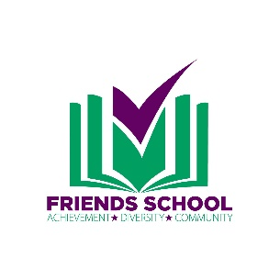
July 18, 2019

Dear Friend,
Friends School is hosting our Annual Auction and Gala Eat, Drink, and Be Tacky on December 7, 2019 and we need your help! The donations of local and regional businesses, organizations, and individuals are integral to the success of our most important fundraising event. I am writing to respectfully request that you make a donation of an item, a service, an experience, a gift card – anything from your wonderful establishment!
Friends School is a non-profit, non-sectarian, family cooperative school. What makes Friends School so incredibly unique is that children of all abilities work, play, and learn together in the same classroom. Our students with special needs are supported by a specialized educational team, comprised of an inclusion coordinator, resource teachers, a speech and language pathologist, a behaviorist, assistants and various consultants, as well as carefully crafted curriculum, equipment and education supports. About 45 – 50 % of our population has been diagnosed with an identified special need including autism, Down Syndrome, Cerebral Palsy, Spina Bifida and various other developmental and physical delays. At Friends School, no matter what the diagnosis or special need may be, every child is valued as a significant contributor to our community.
This year’s event Eat, Drink, and Be Tacky, will be held at The Regency on December 7, 2019. By making a donation to the auction, your business will take pride in knowing that you are supporting a school that is focused on educating and welcoming all children. Friends School’s Auction and Gala attracts 300 attendees from Louisville and the surrounding area. We think you will find that marketing your business, services, and products through our event will be beneficial as you seek out opportunities for positive exposure for your company. By supporting Friends School, your business is showing the Louisville community that you are willing to help tackle the challenges facing so many families today.
Your generosity will support our children, their families, our faculty, and ultimately our mission. If you are interested in seeing our work in action, please contact me for a personal tour. Thank you for your consideration.

Best regards,

Melanie Willis
Business Manager
Tax ID#: 61-1213141
Friends School is a 501 (C)(3) organization. Donations are tax deductible to the extent allowed by law.

